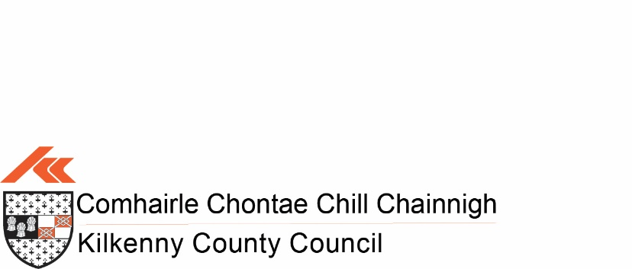
HOUSING DEPARTMENT
SELF HELP SCHEME – 2023
APPLICATION FORM
Tenant: (1)_______________________________ (2)________________________________
Address:________________________________________________________
_______________________________________________________________
Eircode: ________________________________________________________
Rent Account No: ________________________________________________
Contact Telephone No: ____________________________________________
Details of work you wish to apply for the grant (as per scheme guidelines): _____________________________________________________________________________________________________________________________________________________________________________________________________________________________________________________________Is your rent paid up to date? ______________________
Signed: (1)___________________________(2)_______________________________

TWO ITEMISED QUOTATIONS FOR ALL WORKS MUST BE SUTMITTED WITH APPLICATION
NB: Closing date for receipt of applications is Friday 31st March 2023 *************************************************************************** For Office Use Only:
Rent Account:__________________at(date)_______________Current Debit:€
Is Rent Account up to date: ____________________________________________________
Signed: _______________________________________________________________

